**Randolf**

5A- Fast punch to the gut(Like where the fist is at, but with a less anime pose)

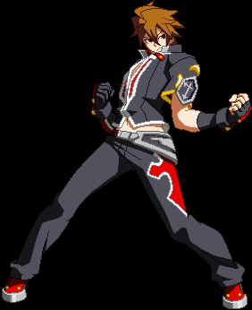

5B- Punch with other hand that reaches farther



5C- Punch with initial hand that reaches the farthest.

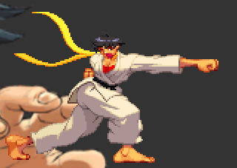

2A- Fast crouching jab

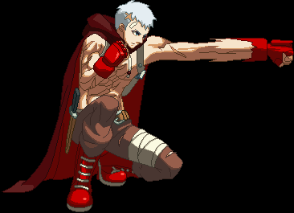

2B- Crouching uppercut

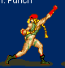

2C- Sweep with one leg that strikes at the feet.

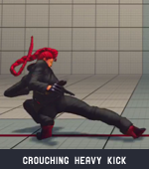

j.A- A quick jab in the air

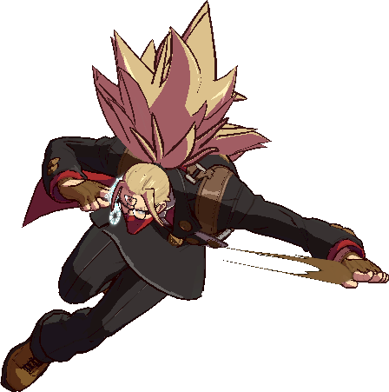

j.B- Upwards kick

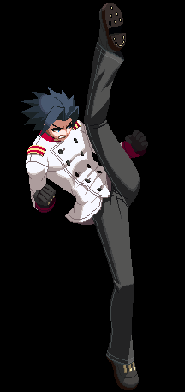

j.C- Downward angled punch

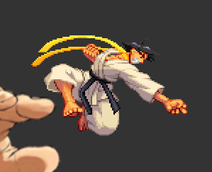

236(A,B,C) for Fireball -- Spirit Wave

Fireball thrown with hand. Speed varies by button press.

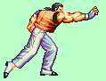

214(A,B,C) for Tackle --Arcane Blitz

A charging shoulder tackle. Distance and startup vary by button press.

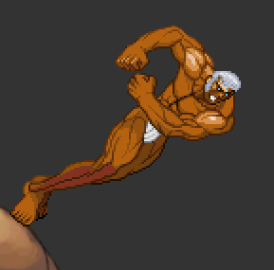

623(A,B,C) for Reversal -- Sky’s Companion

Invincible uppercut that varies in jump height and startup by button press.



63214(A,B,C) for Command Grab -- Return to the Earth

Command grab. Grabs the opponent and suplexes them.

Character Super(236+ any two of A, B or C) -- Holy Warrior’s Rage

Barrage of punches then launches with a jumping uppercut. Upon landing, Randolf throws a large fireball.

Throw(A+E)- Punches with 5B and 5C, launching the enemy away.

**Lynne**

5A- Fast knee attack.

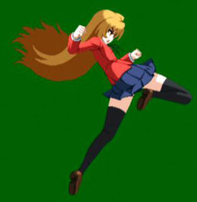

5B- Kicking attack, fully extends leg.

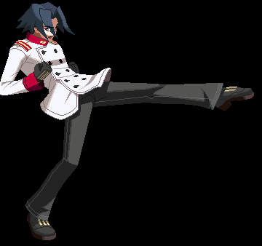

5C- Backwards roundhouse kick that moves Lynne forward.

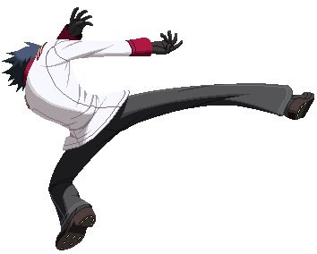

2A- Fast low kick.

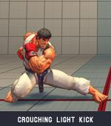

2B- Longer-ranged low kick.



2C- Spinning sweep kick.

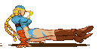

j.A- Air knee attack.

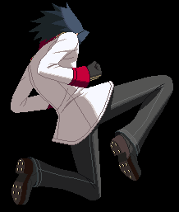

j.B- Far reaching, horizontal kick.

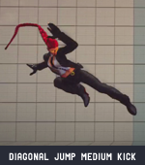

j.C- Jumping kick at a low angle.

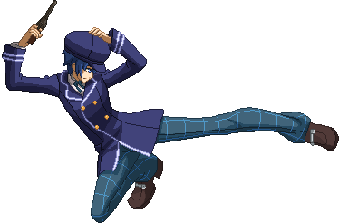

236(A,B,C) for Fireball -- Rage Torrent

Fireball thrown with a kick. Speed varies by button press.(Does not have to reach as high)

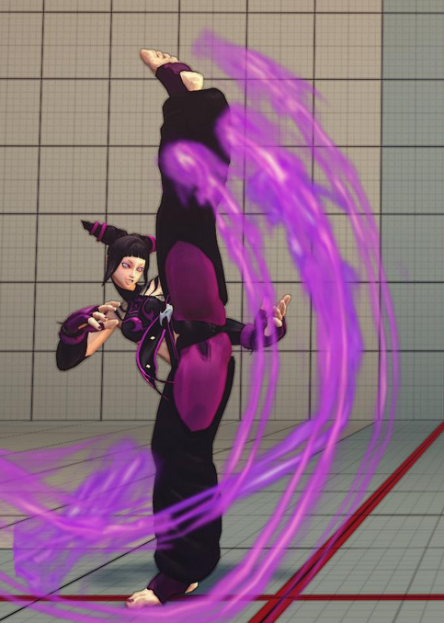

214(A,B,C) for Slide -- Jetstream Slide

Slide kick that’s low to the ground. Has follow ups based on button presses.

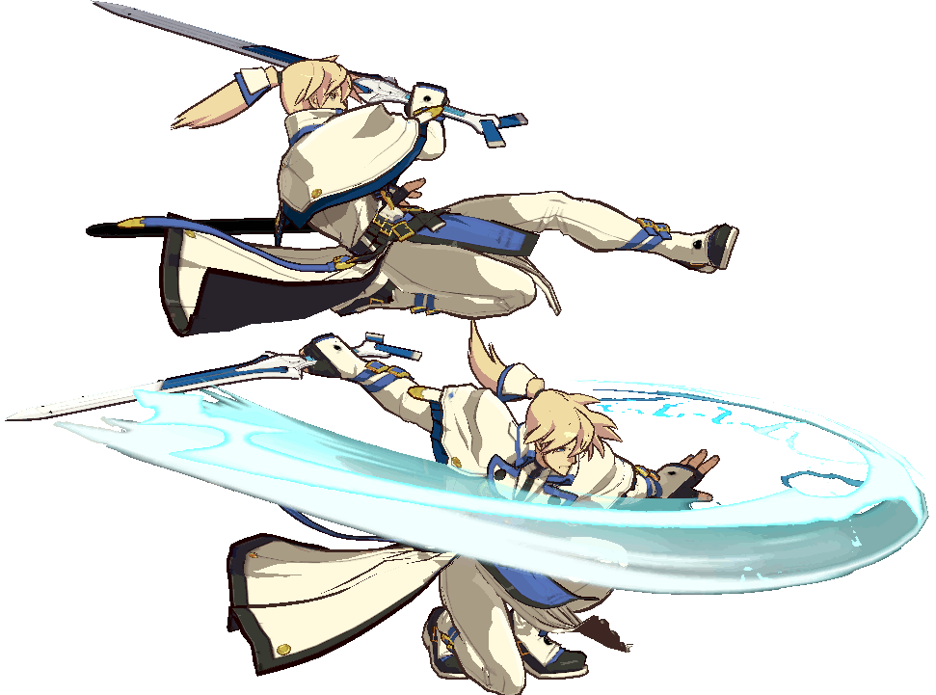

Slide + A for fast follow up -- River

Fastest follow up that hits low. Does not knock down.



Slide + B for Slow low follow up -- Flood

Slower version of 2C that can lead to a combo



Slide + C for Slow high follow up -- Waterfall

Short jump with a swinging kick. Can lead to a combo after hitting.

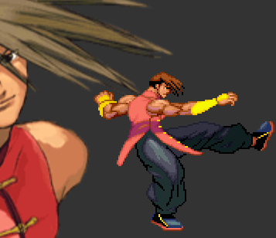

623(A,B,C) for Reversal -- Shooting Star

“Uppercut” with a kick.



Character Super(236+ any two of A, B or C) -- An Outcast’s Justice

Flurry of kicks(with the pose of standing MK), then three of her 623 attacks (Light, medium, then heavy)

Throw(A+E)- After grabbing, she knees the opponent, then kicks them away.

**Elements**

Life

Passive: Specials have minor lifesteal(innate and Life-given specials)

236(E) -- Vine Garden- Set a trap of vines in front of you.

214(E) -- Vine Transit- Envelop yourself in vines and travel underground (Zato BTL)

Element Super(236A/B/C + E) -- Soul Transfusion- Healing field that restores owner HP and decreases enemy HP while they are both in the field. Last 7 seconds.

Death

Passive: Increased chip damage

236(E) -- Acid Rain- Fire a projectile into the air. After 1 second, multiple projectiles fall down in a large radius around the character.

214(E) -- Plague Beam- Fire a beam that reaches throughout the screen. Slower startup than fireballs.

Element Super(236A/B/C + E) -- Impending Death- Summon a slow moving, multi-hitting projectile(Similar to Dormammu’s Stalking Flare)

Space

Passive: Naturally gain more meter from attacking/taking damage

236(E) -- Gravity Armor- Upon activation, the next special move used will have 1 hit of ‘armor’ during the startup and active frames of the move.(‘Armor’ means that if you are hit while you have armor, you take the damage but the move is not interrupted.)

214(E) -- Reality Distortion- Dodge away from the screen and avoid attacks for a short time.

Element Super(236A/B/C + E) -- Spatial Rejection- A large burst of energy comes out from the player. Has invincibility on startup.

Time

Passive: Extra Air Option

236(E) -- Reverse Strike- Perform a quicker version of the elemental casting pose to reduce the overall recovery of whatever attack this was special cancelled from.

214(E) -- Alter Perception- Slow moving projectile that deals no damage, but causes the opponent to move slower for a short amount of time.

Element Super(236A/B/C + E) -- Time Skip- Quickly rushes forward and attacks the opponent. Projectile invincible. (Johnny’s SDTH)